|  |
| --- |
| SCM HW3 Group 1 |
| Optimizing Product Pricing |
| Syracuse University |

|  |
| --- |
| Nicholas Starr, Jared M Mosley & Sathish Kumar Rajendiran  5-23-2020 |

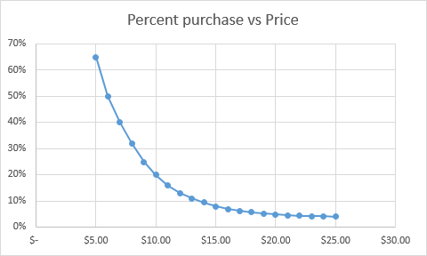**The Problem**

The Book Emporium has provided us data of different demand for the Harry Potter book 7 at different price intervals. Based on the underlying data, to the right is a graph of the percent purchased against the price.

With a new Harry Potter sequel on the horizon, we will attempt to evaluate the best potential price for the new book.

**The Regression Analysis**

Using power regression, we will determine the predicted percentage of sales. To the right is our regression analysis and a graph reflecting the predicted sales percentage.

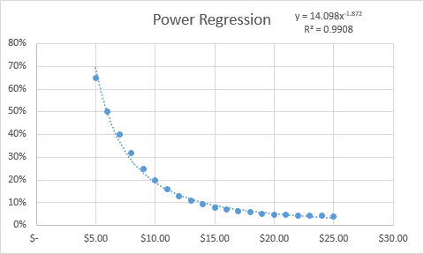We can estimate the equation of the new line is y = 14.098x-1.872

Our R2 is .9908 for this equation, and that means the data is likely artificial as it is unrealistically high. For the predicted equation, 99.08% of variation in the Y variable is explained by our X variable.

Assuming 100,000 customers at each interval, as well as a $5 publisher cost, we can calculate predicted sales, revenue, and profit at each price point.

**The Optimization Analysis**

Using solver with some constraints, we can determine the best prices and profit yields of various outcomes. Assuming the publisher will sell us the books at $5.00 each and no minimum order, we can determine that the optimal price is $10.73, with $95066.44 of expected. In a different scenario the publisher is willing to sell the books at $4.50 so long as we have at least 30,000 sold. Under these conditions, the optimal price point is $7.82, and we can expect a profit of $99586.53. In a third scenario, the publisher has agreed to sell the books at $4.00 if we sell at least 50,000. For these constraints, our optimal price point is $5.95, with a total expected profit of $97606.83.

With these three scenarios, we would opt for the second scenario, selling at least 30,000 units with a cost of $4.50. This option will net the highest expected profit among alternatives.

**The Risk**

Looking at Harry Potter 7 data in predicting the outcome of an eight book, we feel that the main risk is that it has been a long time since the last book release. Harry Potter 7 came out 13 years ago, only a decade after the series began, indicating the data might not be representative of how modern audiences would receive a Harry Potter sequel.

**Additional Data**

We feel it would be beneficial to have some data on recent Harry Potter products (films, stage play, general merchandise) as well as data on more modern novels in the same young adult fantasy genre. This data would give a better indication of how readers in 2020 would engage with a new Harry Potter novel.